Setting up your new computer
Use this quick guide to set up your new Windows computer.
If you have not yet enabled multi-factor authentication (MFA) for your account, install the Microsoft Authenticator app from the Google Play Store or Apple App Store, and follow the instructions at: https://ict.oulu.fi/16893/
Turn on the computer, connect to a network, and log in using your account (username@univ.yo.oulu.fi OR username@oamk.fi) and password.
The setup process may take some time. If it appears to be stuck in a single step for 20 minutes or longer, turn off the computer by holding down the power button for about 30 seconds, then turn it back on.
You can enable facial recognition for login if you wish, or skip this step. This feature can also be enabled later.
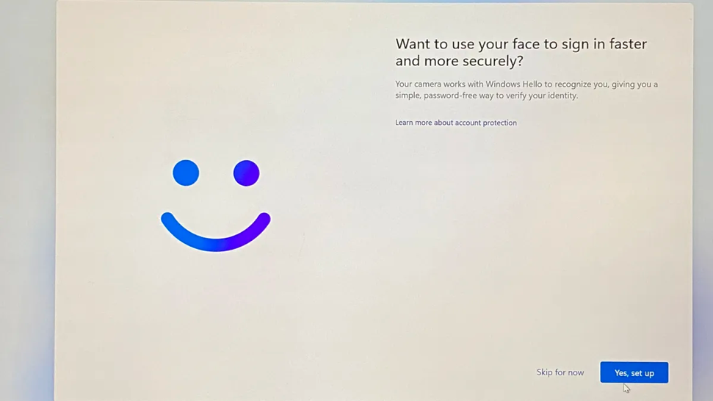
Set a PIN code with at least 6 digits. From now on, you will primarily log in using this code. However, logging in with your password will still be possible.
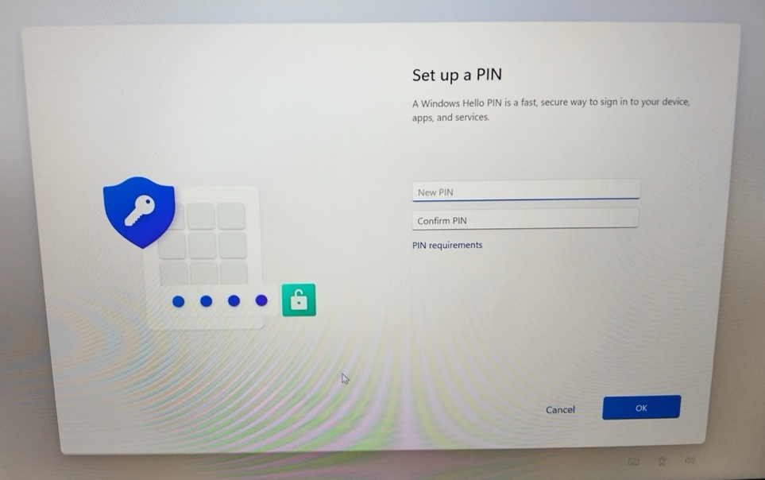

File management and storage
OneDrive is the default storage recommended by ICT services and is automatically available to you.
If you wish, you can also add your old home directory (K:) using the Map Network Drive function. Open File Explorer and right click on This PC, and select Map Network Drive.
Your home directory is located at: \\lipasto.oulu.fi\kotidir0X$\tunnus,
The number replacing X depends on the first letter of your username.
• a-g \\lipasto.oulu.fi\kotidir01$\username
• h-j \\lipasto.oulu.fi\kotidir02$\username
• k-l \\lipasto.oulu.fi\kotidir03$\username
• m-o \\lipasto.oulu.fi\kotidir04$\username
• p-s \\lipasto.oulu.fi\kotidir05$\username
• t-z \\lipasto.oulu.fi\kotidir06$\username
Instructions: https://ict.oulu.fi/1343/
OUAS staff can add the shared network drive using the path \\kaappi.oulu.fi\oamk$.
For university staff, the faculty’s shared network drive (S:) is connected automatically.
Accessing network drives requires a campus network or VPN connection.
Your computer already has the VPN application FortiClient installed. Open FortiClient, select either UniOulu VPN or OAMK VPN, and click Connect.
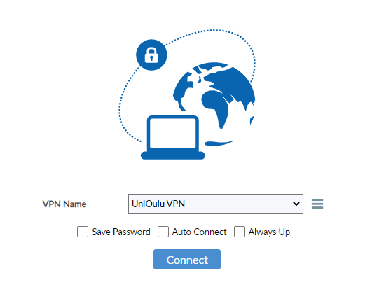
Note! You can also install the OpenVPN application yourself from the Company Portal app. To use OpenVPN, you need a VPN profile. Create the profile by following the instructions at: https://ict.oulu.fi/20988/ (UO) or https://ict.oulu.fi/18295/ (OUAS).

Installing Applications
You can install additional applications on your computer from the Company Portal. To find it, type Company Portal in the Windows search bar. Select your desired application and click Install. Office applications and the FortiClient VPN application are already pre-installed.
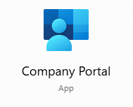
If you cannot find the application you need in Company Portal, you can send an installation request directly to ICT by right-clicking the application’s installation file and selecting Run with elevated access. Once the request is approved, you can complete the installation using the same Run with elevated access option. If you face any issues with the installation, please contact IT support.
Instructions: https://ict.oulu.fi/22330/

Printing
Add printer queues by installing the University Printers application from Company Portal. This requires either a campus network or a VPN connection.
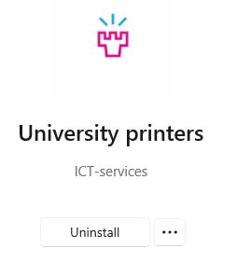

Sign in to your Chrome or Edge profile, or import the bookmarks you saved from your old computer into your preferred browser.

Updating your computer
Windows updates are installed automatically about once a month.
Device drivers will auto install automatically over time. However, if you want to check for driver updates and install them manually, you can use the Lenovo System Update application. The application is available in Company Portal.
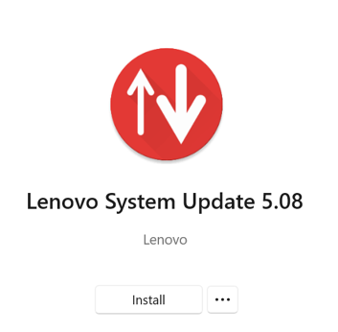
Open Lenovo System update by typing System Update in the Windows search bar. Click Next and wait while the program loads all available driver updates. Click Select all, then click Next to install then. Finally, restart your computer.
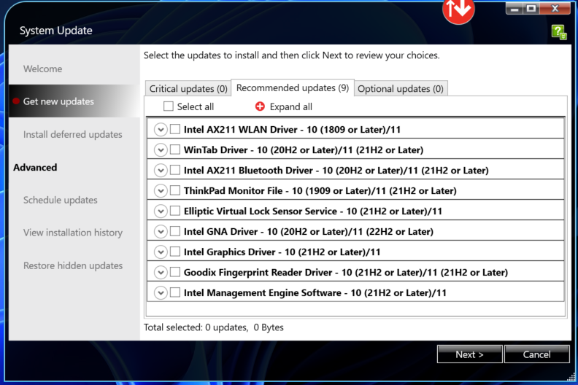

Troubleshooting
Our IT support team is happy to assist if you have any questions or encounter issues while setting up your new computer. You can submit a support request or call our helpdesk during opening hours. On the ICT Services public help site, you will find up-to-date opening hours as well as information and instructions for various topics.
If needed, ICT Services can provide remote assistance using the Remote Help application, which is already installed on your computer. For this, you will need the device ID, which can be found on the service device label.
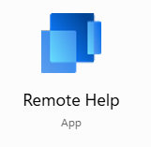
Support Requests: ict@oulu.fi
Phone: 0294 483124
ICT Services Help Site: http://ict.oulu.fi

